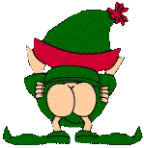

Life is all about asses
you're either covering it,
laughing it off,
kicking it,
kissing it,
busting it,
trying to get a piece of it,
or behaving like one ......
That's right, you've been " elfed " . Pass this on to as many people as possible, but you can't send it back to the person who sent it to you. He who elfs last, elfs loudest!!!!

